Prompt Lists
Design Handoff to Codex

You are working on an existing Patch codebase. This is NOT a new project.
I already have working frontend/backend functionality, and I now have approved frontend designs that I want implemented.
Your job is to update the existing UI to match the provided designs as closely as possible while preserving existing functionality.
Before making changes:
- Inspect the relevant existing code and understand how the screen currently works.
- Reuse existing components and logic whenever possible.
- Do not rebuild working functionality unnecessarily.
- Do not change backend/API/state logic unless required by the new design.
- Do not redesign the provided UI. Treat the design as the visual source of truth.
- Keep changes focused only on the screen/task I assign.
- Check for shared components before creating duplicates.
- Preserve responsive/mobile behavior.
For each design I send:
- compare it with the current implementation
- identify what needs to change
- implement it
- preserve existing behavior
- run relevant tests/typecheck/build
- report any remaining differences from the design
When multiple Codex sessions are running, avoid modifying unrelated files or overlapping with another agent's task.
Default assumption:
When I say "implement this design", I mean:
Update the existing implementation to match this design. Do not create a separate version or rebuild the feature from scratch.

Design 01 - Home / Empty State
Purpose:
This is the Home experience for a new user who has no learning material yet. It should make the next action immediately obvious and begin building their learning experience.

Requirements
- Show personalized greeting: Hello [name]
- Supporting message: Ready to learn?
Show the mascot prominently in the center
- Primary CTA: Add material
- CTA should open the existing Create flow
- Update the bottom navigation to Home | Sets| Create | Progress | Profile
- Do not show streaks, learning paths, progress cards, or other learning content
- Preserve generous whitespace and the minimal layout shown in the design
- Use existing user/account data for the name; do not hardcode Yota

Goals [optional]:
- Make onboarding feel simple and approachable
- Give the user one obvious next action
- Avoid overwhelming a new user with features before they have material
- Establish the Patch visual identity immediately

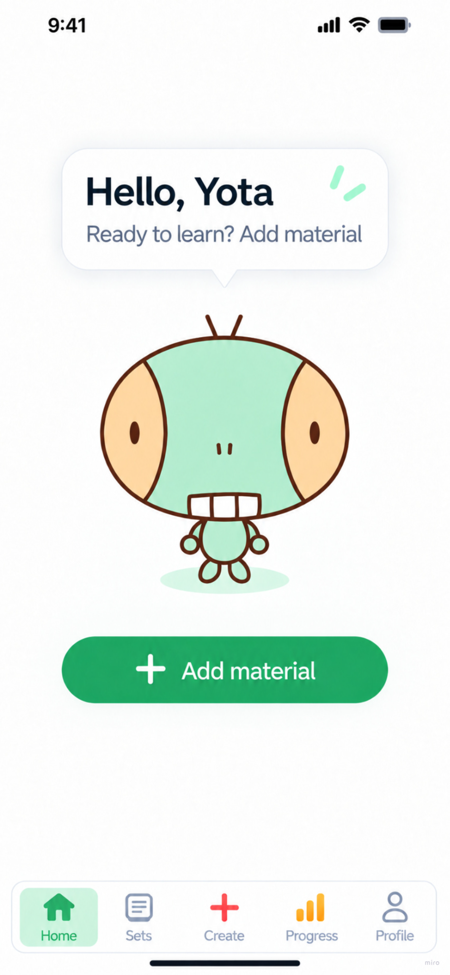

Design 02 - Home / Active State
Purpose
This is the main Home experience once a user has learning material. It should immediately communicate what the user should learn next while reinforcing daily consistency through the streak and learning path.
Requirements
- Show mascot + personalized greeting
- Show the user's current streak
- Show the learning path
- Keep Continue learning as the primary CTA
- Show completed lessons above the current lesson
- Show locked/upcoming lessons below it
- Show milestone nodes where applicable
- Use dynamic lesson names, progress, dates, and streak values

Streak states
Normal streak: 1–4 days
- Label: Study streak
- Green completed-day checks
- Show current streak count
- Supporting message can indicate progress toward Hot Streak
Hot streak: 5+ days
- Label: Hot streak
- Orange/yellow visual treatment from the design
- Orange/yellow completed-day checks
- Show current streak count
Broken streak
- Trigger when the user skips a full day without completing a lesson
- Reset current streak to 0 days
- Use grey/inactive styling
- Show: Missed a day? Let’s get back to it!
- Today appears incomplete

Learning path states
- Completed lesson = green outline/check
- Current lesson = large green Continue learning node
- Upcoming lesson = locked/inactive
- Milestone = orange highlight
- Keep the same learning path structure regardless of streak state

Goals
- Make the next lesson unmistakably clear
- Create a sense of visible learning progress
- Encourage daily consistency without making streaks the main product
- Keep the interface simple even as learning data becomes more complex

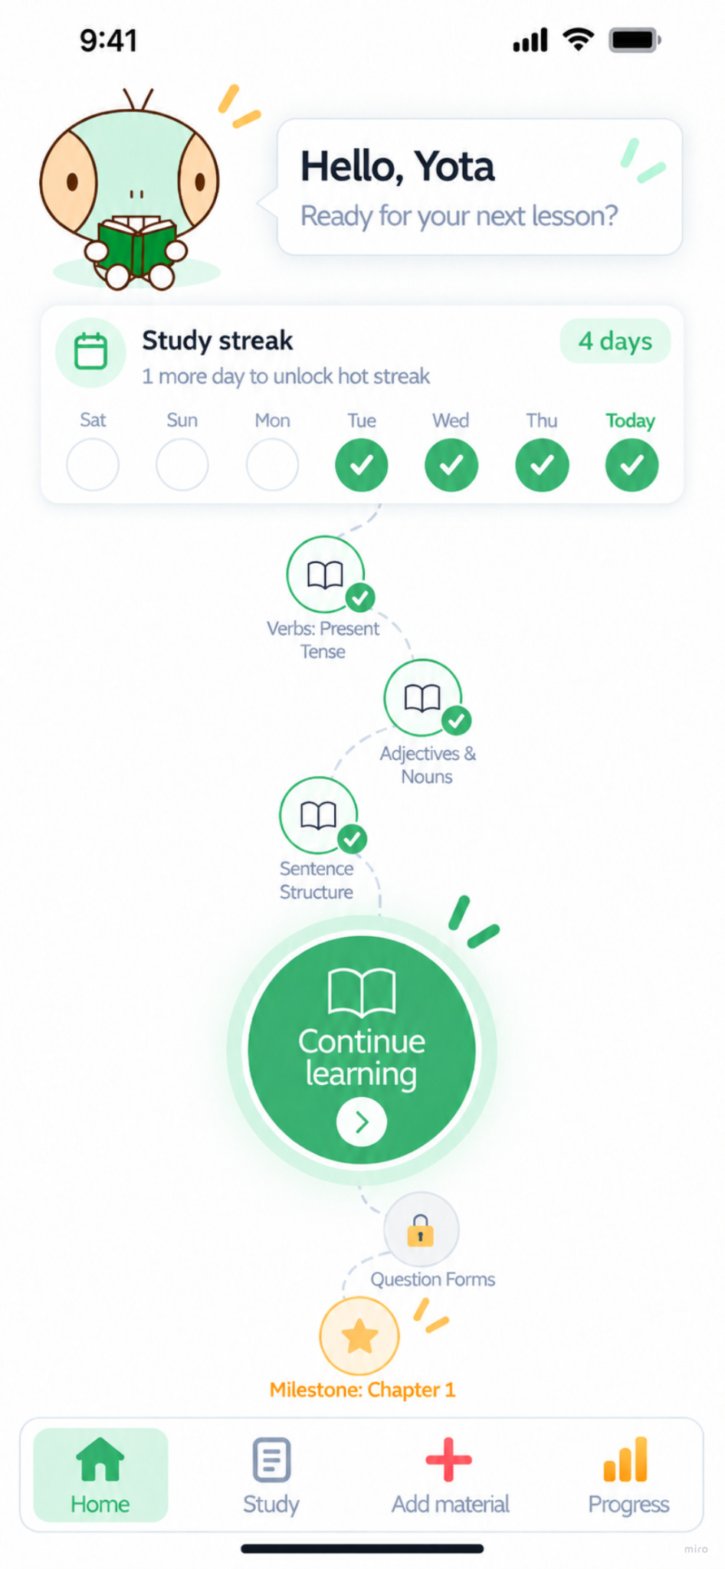
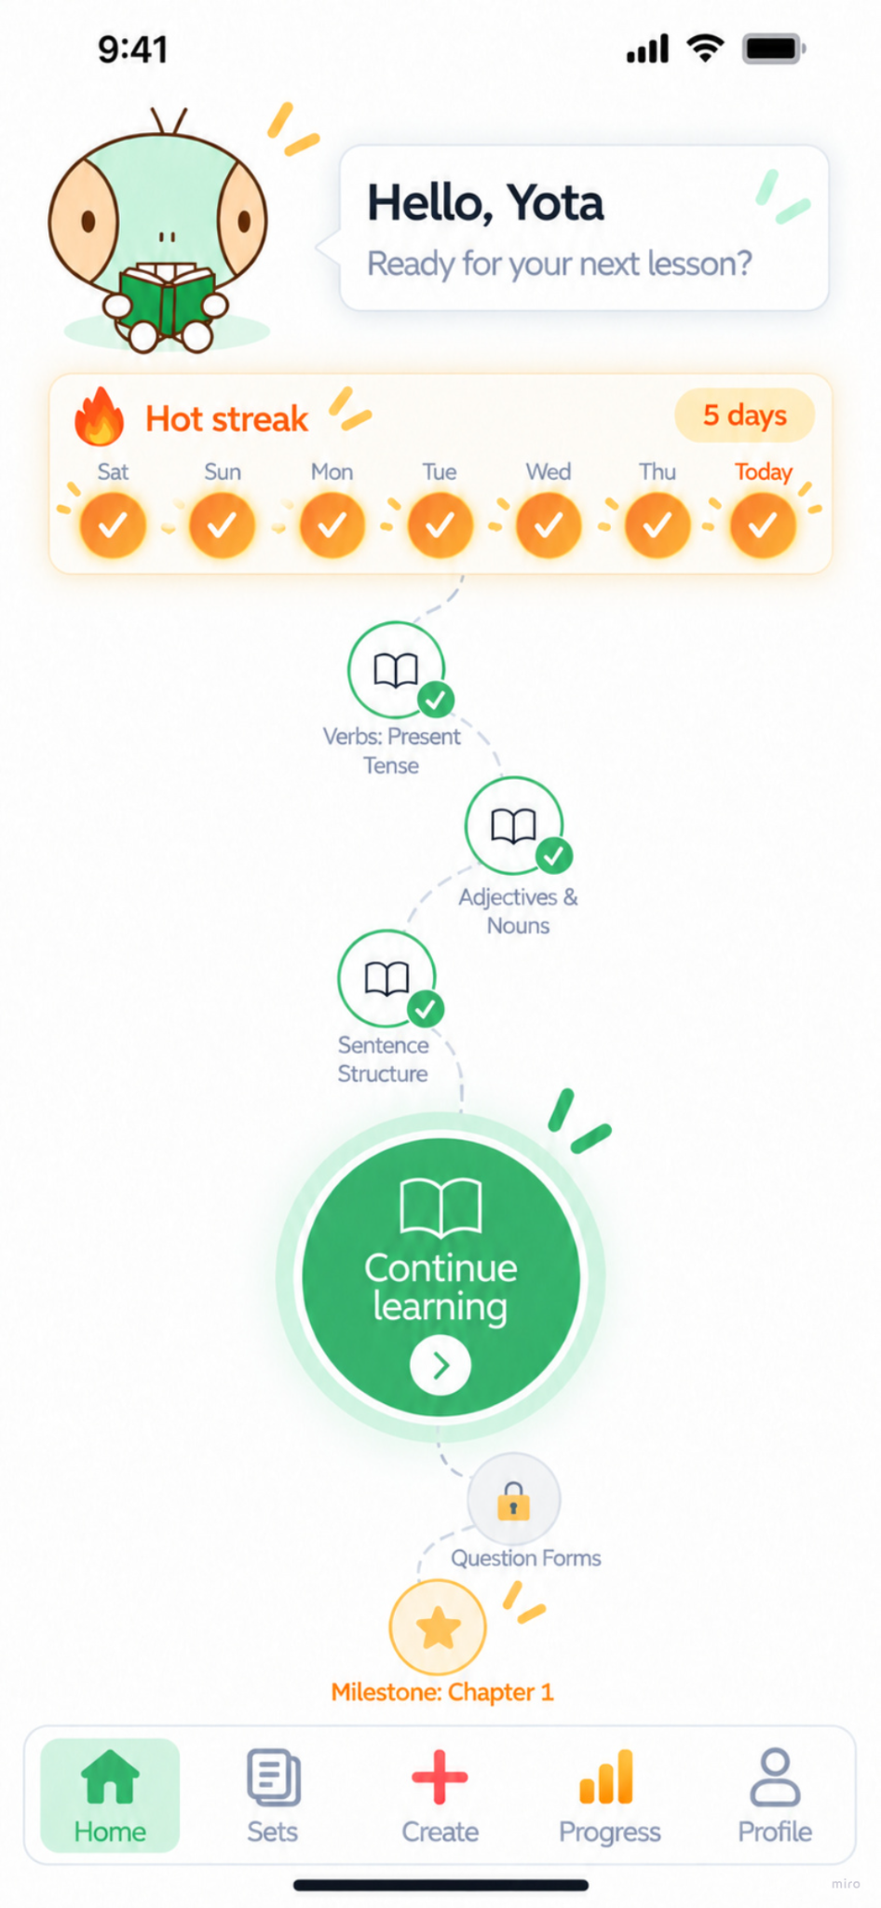
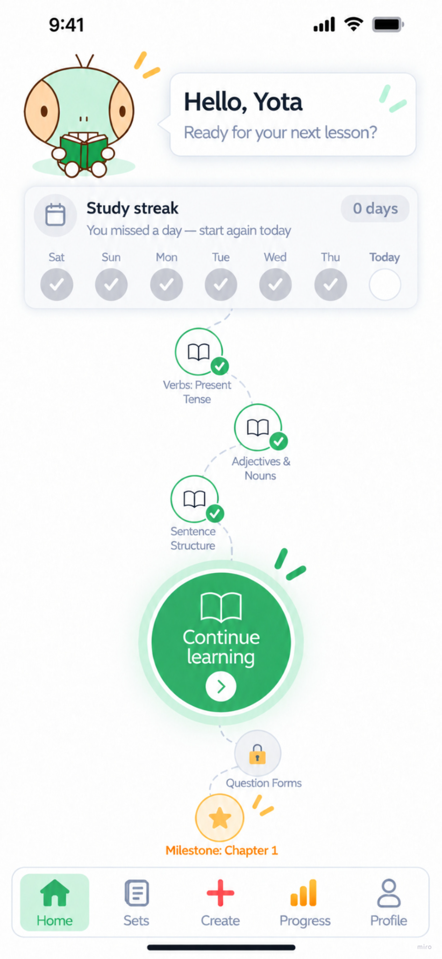

Design 03 - Continue Learning / Lesson Preview
Purpose
This screen gives the user a quick preview of today's lesson before starting it. It should provide enough context to create commitment without adding unnecessary friction.

Requirements
- Open when the user taps Continue learning
- Display as a bottom sheet/modal over Home
- Dim the Home screen behind it
- Show:
  - Today's My Lesson
  - lesson/topic title
  - estimated duration
  - short lesson description
  - mascot
  - Start My Lesson CTA
  - close button
- Title, duration, and description must come from the current lesson data
- Do not hardcode AI Agents, 7 minutes, or other mockup content
- Close button dismisses the sheet and returns to Home
- Start My Lesson enters the existing lesson flow
- Do not create a separate page unless required by the existing architecture

Goals
- Tell the user exactly what they are about to learn
- Set a clear time expectation
- Reduce uncertainty before starting
- Make starting the lesson feel like a lightweight, intentional action
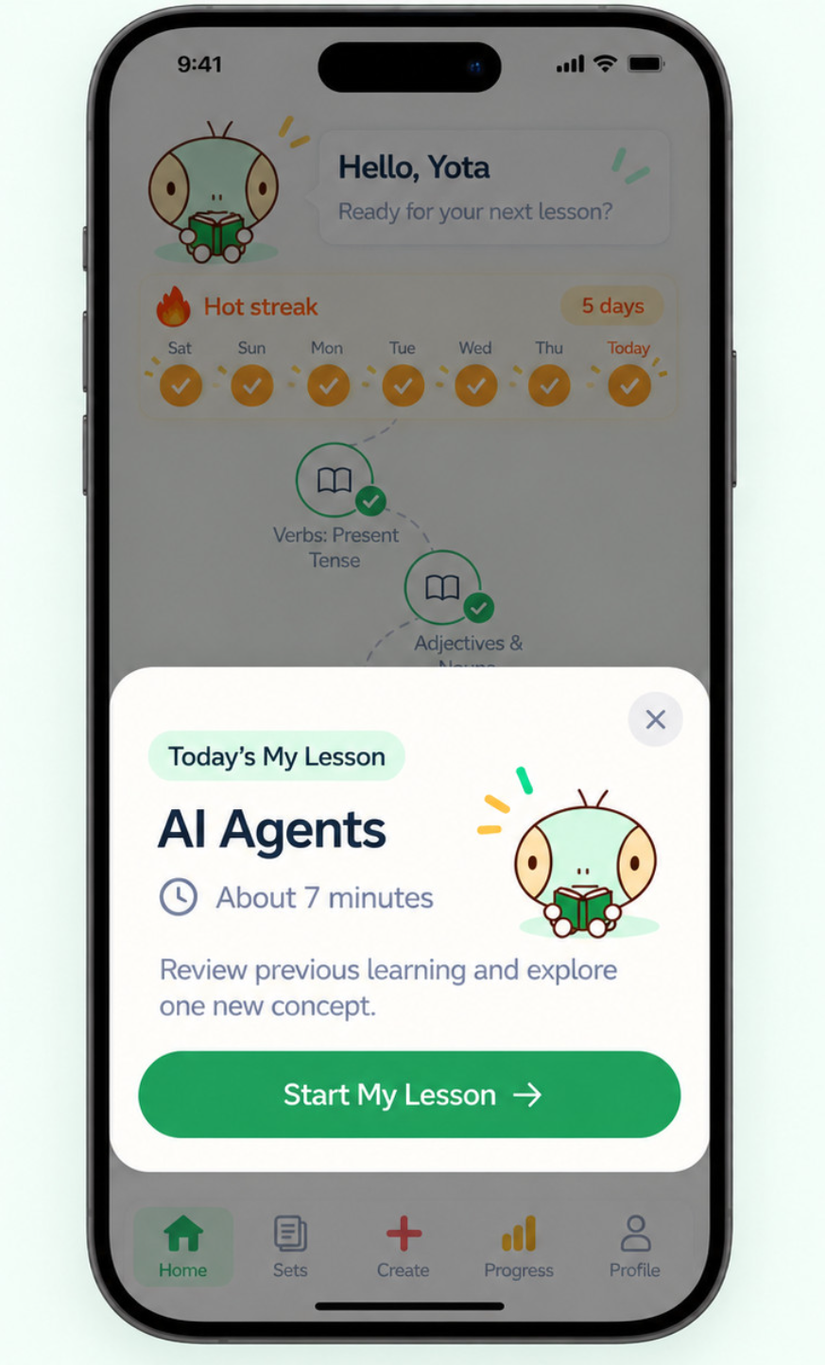

Design 04 - Lesson Complete / Post-Lesson Home
Purpose
This experience confirms that the user's daily learning goal has been completed, summarizes the value of the session, and then gives them the option to continue learning without making additional study feel required.

Requirements

Lesson Complete screen
- Show celebratory mascot
- Show Lesson complete!
- Show personalized success message
- Display dynamic lesson results:
  - concepts reviewed
  - weak spots strengthened
  - new concepts learned
- Show updated streak status
- Primary CTA: Back to Home
- Use actual lesson results; do not hardcode the mockup values

Home after lesson completion
- Mark today's daily lesson as completed
- Replace Continue learning with Done for today
- Update today's streak status
- Keep the learning path visible
- Keep completed/current/upcoming lesson progression accurate
- Change greeting/message to reflect that today's goal is complete

Optional continued learning
Show a Keep going (optional) section below the completed daily lesson.
Possible actions:
- Explore something new
- Strengthen your memory
These must remain secondary to the completed daily goal.

Goals
- Give the user a clear sense of accomplishment
- Show tangible evidence of what they achieved
- Reinforce the streak after successful completion
- Clearly communicate that the required learning for today is finished
- Allow motivated users to continue without making additional learning feel mandatory

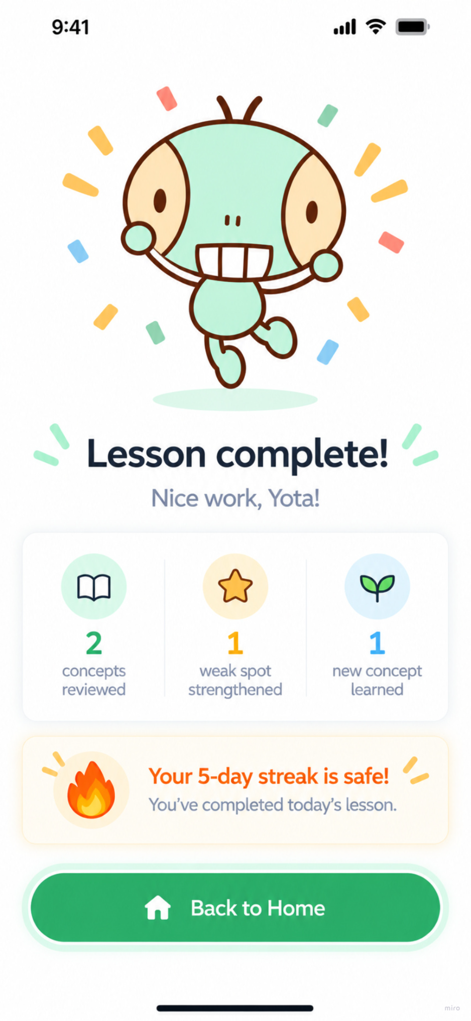
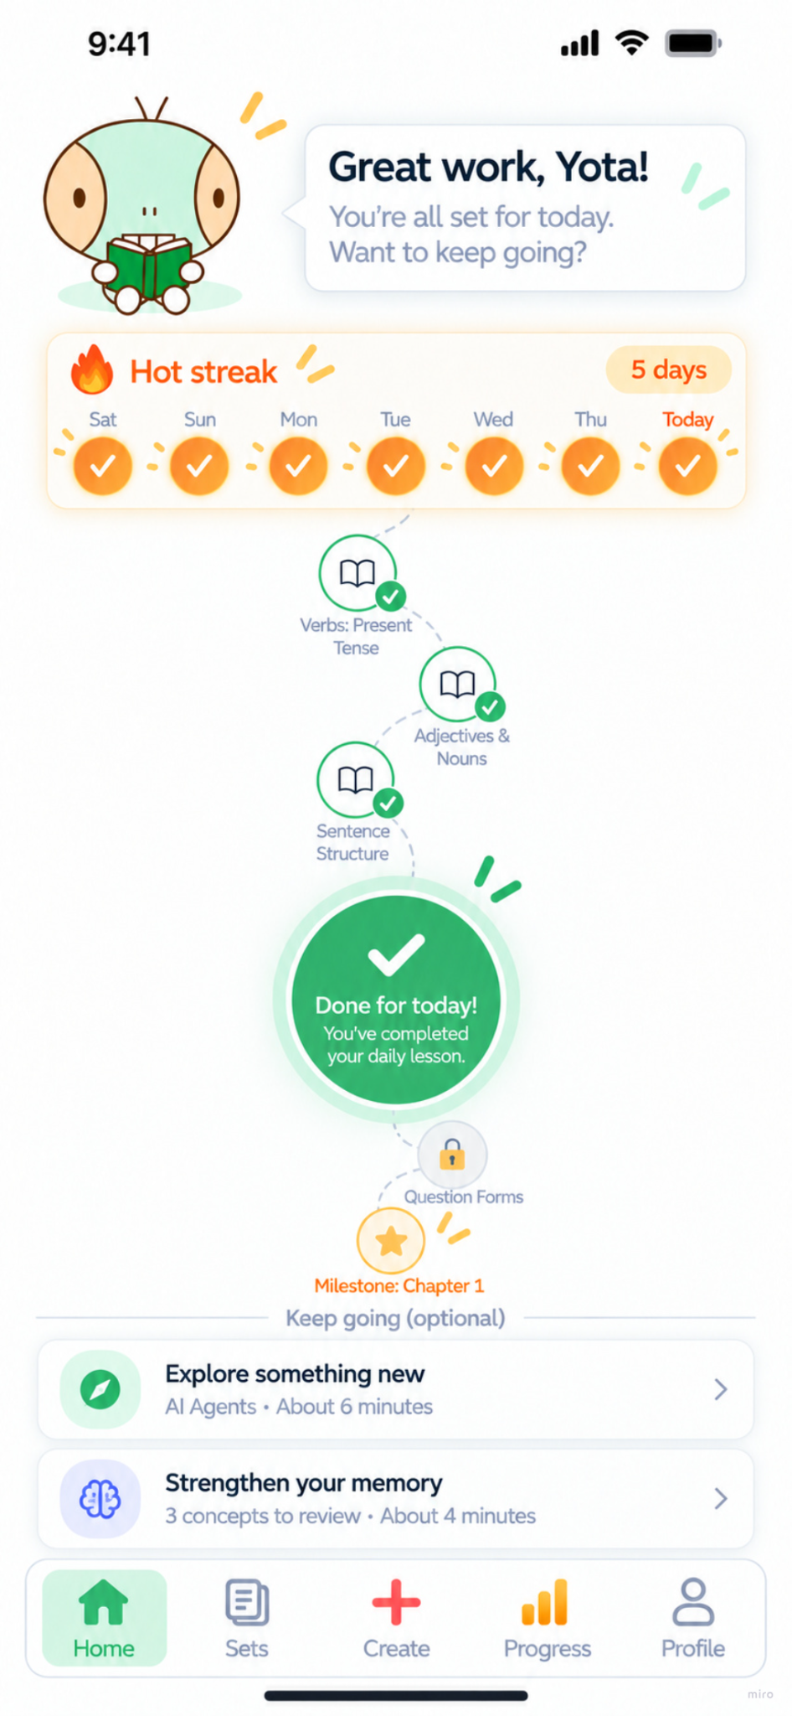

Create Page (no prompt yet)
